Update Security group created

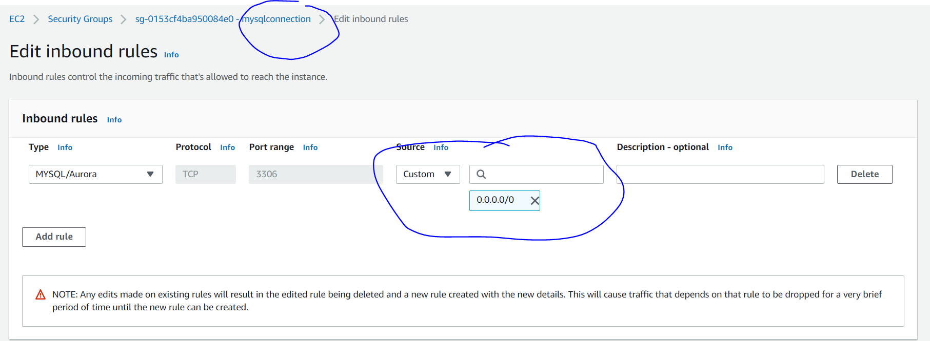

Follow the steps below to connect MySQL Workbench to your Amazon RDS DB instance:

1. Download and install [MySQL Workbench.](https://dev.mysql.com/downloads/workbench/)
2. Open MySQL Workbench, and choose the ⊕ sign beside MySQL Connections to set up a new connection.

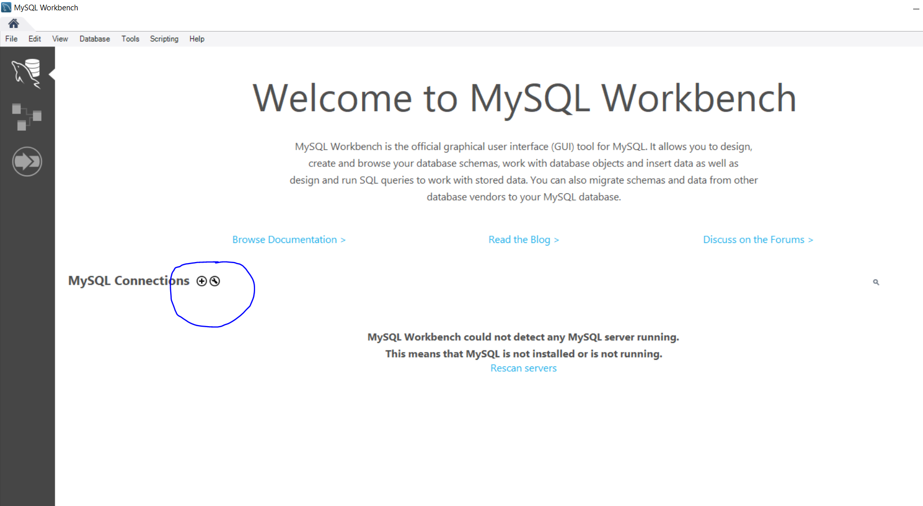

1. In the Setup New Connection dialog box, enter a suitable name for your connection.
2. In the Parameters section, enter the following details:
   * Host name: Enter the RDS endpoint
   * Port: Enter Port the number
   * Username: Enter the master user

Note: You can get these details from the [Amazon RDS console](https://console.aws.amazon.com/rds/home). From the Databases section, choose Instances, and then select the instance that you are connecting to. From the Connectivity and Security tab, click on Configuration. The master user is listed here.

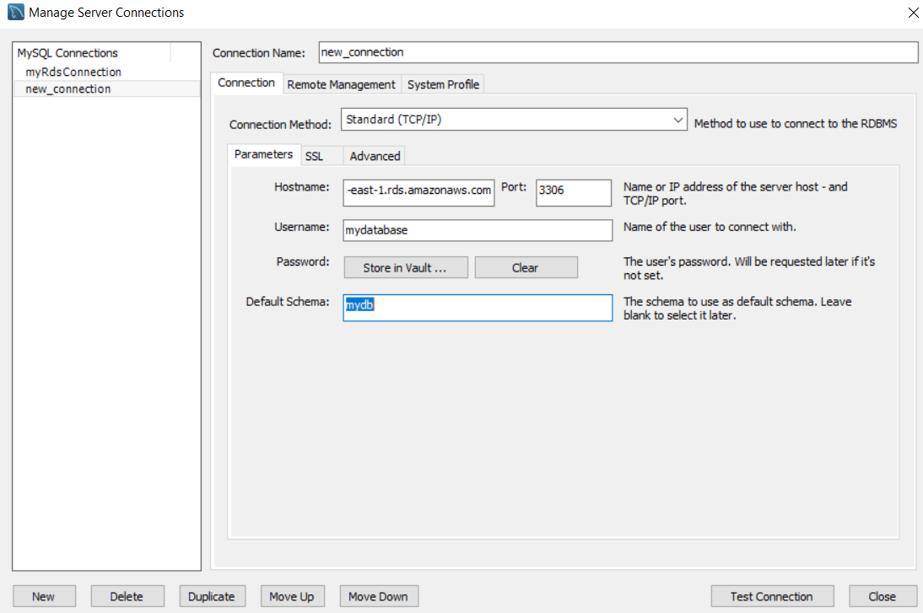

1. Choose Test Connection.
2. In the popup that appears, enter the password that you configured when you created the DB instance, and then choose OK.
3. After testing your connection, from the Setup new connection dialog box, choose OK to save the connection

